Suppression of Central CX3CR1 Signaling Alleviates Amyloid-induced Memory Deficiency
Jiang Wu, Bihua Bie, Hui Yang, Jijun J. Xu, David L. Brown and Mohamed Naguib
Anesthesiology Institute, Cleveland Clinic
The abnormal accumulation of amyloid fibrils in the brain is pathognomonic of Alzheimer’s disease. Amyloid fibrils induce significant neuroinflammation characterized by the activation of microglia and impairment of synaptic plasticity in the brain that eventually leads to cognitive decline. Chemokine fractalkine receptor (CX3CR1) is primarily located in the microglia in the brain and its role in the amyloid fibril-induced neuroinflammation and memory deficiency is debatable. We found that bilateral microinjection of amyloid-beta (Aβ_{1–40}) fibrils into the hippocampal CA1 area of rats resulted in significant upregulation of CX3CR1 mRNA (Fig. 1A) and protein expression (Figs. 1B and 1C) (via increasing histone H3 acetylation in Cx3cr1 promoter region, Fig. 1D), synaptic dysfunction (Figs. 1E and 1F), and cognitive impairment (Figs. 1G and 1 F), compared with our control group. Suppressing CX3CR1 signaling with CX3CR1 siRNA in rats injected with Aβ_{1–40} fibrils blunted Aβ_{1–40}-induced CX3CR1 upregulation, microglial activation (Figs. 1I-1L) and IL-1β expression,(Figs. 1M and 1N) and restored basal glutamatergic strength and electric stimuli-induced long term potentiation(Figs. 1E and 1F), and cognitive capacities (Figs. 1G and 1F). Microinjection of Aβ_{1–40} fibrils did not induce significant change in the expression of fractalkine in the hippocampal CA1 area (Figs. 1O and 1P). These findings suggest that activation of CX3CR1 plays an important role in the neuroinflammatory response and Aβ-induced neuroinflammation and neurotoxicity.
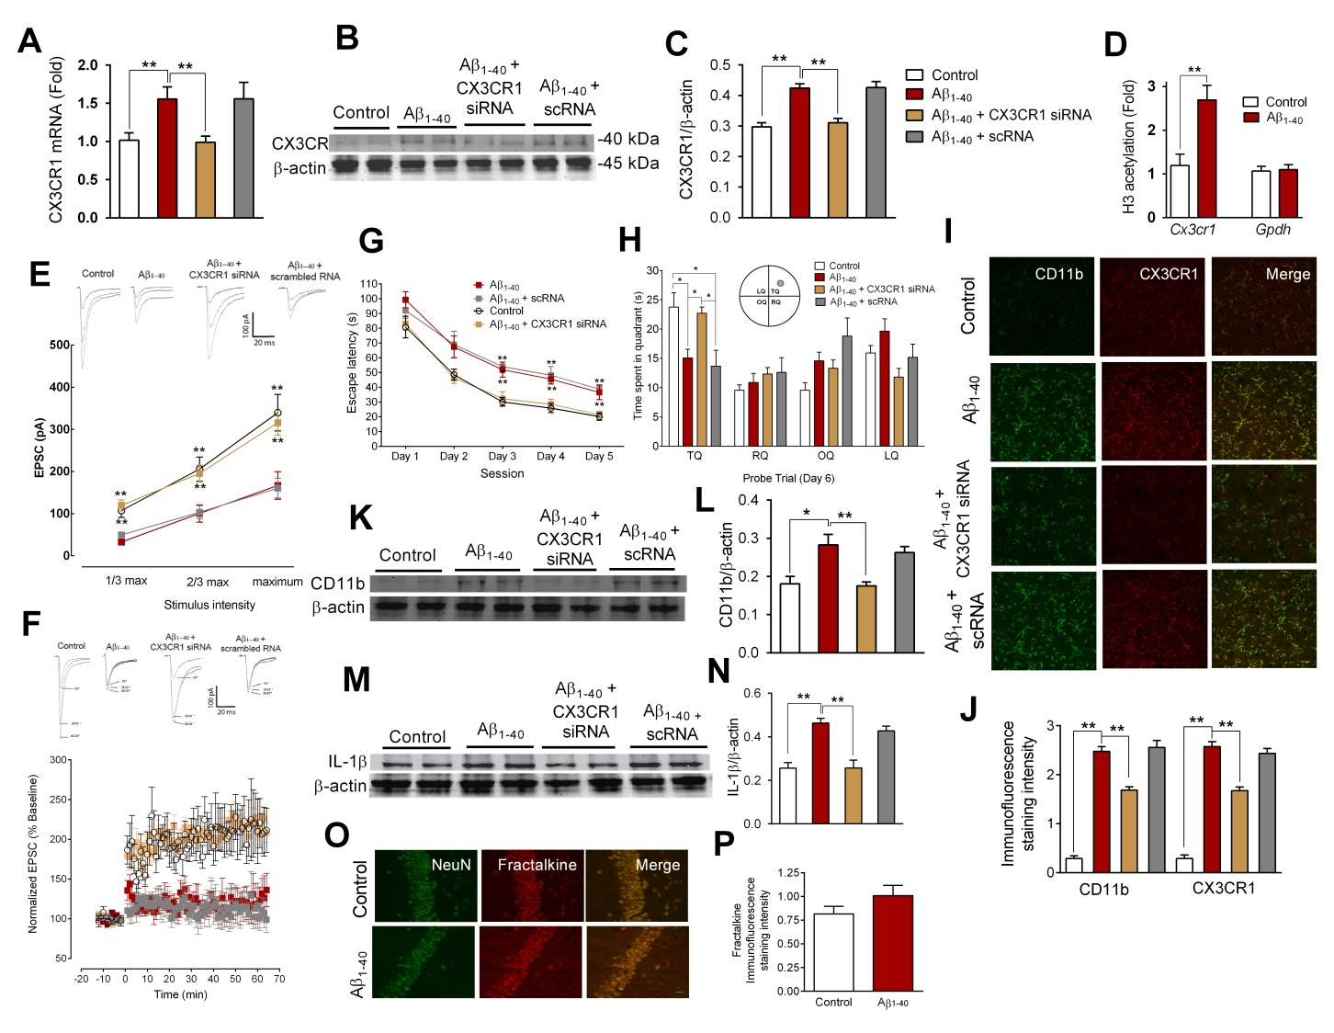
Fig. 1. Scale bar = 20 µm, scRNA = scrambled RNA, n = 6-12 per group. Data are shown as mean ± SEM. ** P<0.01, * P<0.05.

