A Semi-Mechanical PK-PD Model for Rocuronium and Sugammadex to Quantify Covariate Effects and Enable Prediction of (Reversal) of Neuromuscular Block in Various Scenarios

Huub J Kleijn¹, MSc, Rik de Greef¹, MSc; Michiel van den Heuvel¹,MSc; Pieter-Jan de Kam¹, PhD; Thomas Kerbusch¹, PhD; Daniel Zollinger², PhD; Marie-Jose Lierop¹, PhD

¹ Merck Research Laboratories, Whitehouse Station, NJ, US; ² Okklo lifescience BV, Oss, The Netherlands

introduction: An integrated population pharmacokinetic-pharmacodynamic model was developed with the following aims: to simultaneously describe pharmacokinetic behaviour of sugammadex and rocuronium; to establish the pharmacokinetic-pharmacodynamic model for rocuronium-induced neuromuscular blockade (NMB) and reversal by sugammadex; to evaluate covariate effects and explore impact on reversal time; to simulate re-use of rocuronium after sugammadex treatment.

METHOD: Data were pooled from ten clinical studies (n=513). The sample included men, women, non-Asians, Asians, pediatric, adult, and elderly patients with various degrees of renal impairment. Modelling techniques based on physiological principles were applied to capture rocuronium and sugammadex pharmacokinetics and pharmacodynamics and to identify and quantify covariate effects.

RESULT: Sugammadex pharmacokinetics were mainly affected by renal function. Simulated reversal times in typical adults were 0.8, 1.5 and 1.4 min upon immediate reversal¹, deep block reversal², and moderate block reversal³, respectively. Simulations indicated that reversal was faster in pediatric patients and slightly slower in elderly patients compared with adults. Renal function was predicted to not affect reversal time, but to substantially affect clearance of sugammadex and the sugammadex-rocuronium complex. A dose of 1.2 mg.kg⁻¹ rocuronium for re-use after moderate block and deep block reversal was equipotent compared to the initial intubation dose, at all simulated re-use times (range 5 to 480 min) for all evaluated populations.

CONCLUSION: The PK-PD model provided accurate predictions of sugammadex reversal times in various patient populations with predicted reversal time in typical patients always <2 min. NMB can effectively be re-established after sugammadex moderate and deep block reversal.

(1) Immediate reversal defined as 16 mg.kg-1 sugammadex at 3 minutes after 1.2 mg.kg-1 rocuronium
(2) Deep block reversal defined as 4 mg.kg-1 sugammadex at 1-2 PTCs
(3) Moderate block reversal defined as 2 mg.kg-1 sugammadex at reappearance of T2

Figure Schematic overview of the PK-PD interaction model of rocuronium and sugammadex
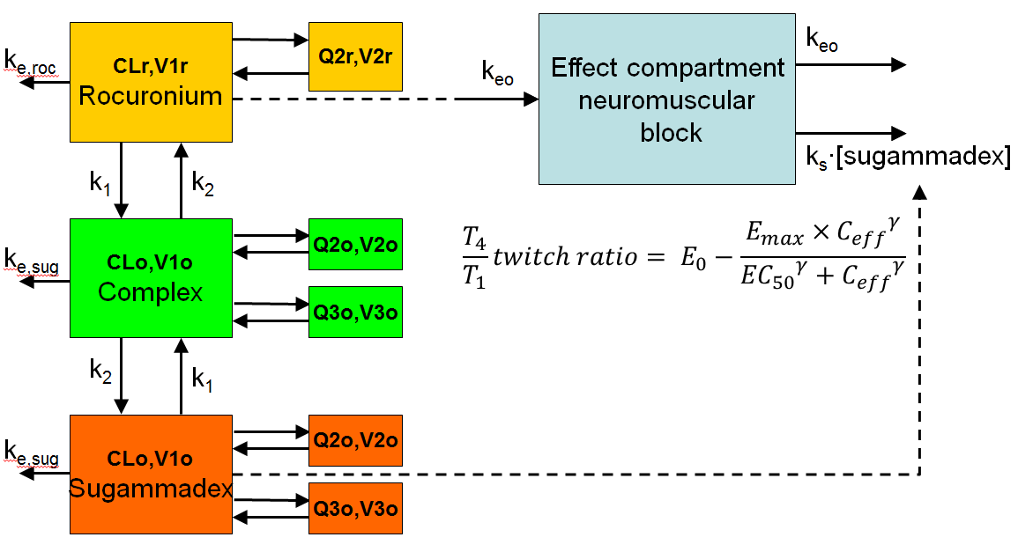
CLr, rocuronium clearance; CLs, sugammadex or complex clearance; k1, rate constant of association between sugammadex and rocuronium; k2, rate constant of dissociation; ke,Roc, rate of elimination of rocuronium; ke,Sug, rate of elimination of sugammadex or complex; keo, distribution rate constant between central and effect compartments; ks, rate constant; Q2r, intercompartment clearance of rocuronium from the central to the peripheral compartment; Q2s, intercompartment clearance of sugammadex or complex from the central to the 1st peripheral compartment; Q3s, intercompartment clearance of sugammadex or complex from the central to the 2nd peripheral compartment; V1r, volume of distribution of rocuronium in the central compartment; V1s, volume of distribution of sugammadex or complex in the central compartment; V2r, volume of distribution of rocuronium in the peripheral compartment; V2s, volume of distribution of sugammadex or complex in the 1st peripheral compartment, V3s, volume of distribution of sugammadex or complex in the 2nd peripheral compartment .
E0 is the baseline T4/T1 twitch ratio; Emax (set equal to E0 for each individual) is maximal reduction in neuromuscular function corresponding to full muscle relaxation, i.e. T4/T1 twitch ratio of 0; Ceff is the rocuronium concentration in the effect compartment; EC50 is the rocuronium concentration in the effect compartment required to produce a 50% reduction in neuromuscular function; and γ is the Hill coefficient.

