Efficient Assessment of Pregabalin Combined with Morphine Using in Patients with Neuropathic Cancer Pain

Zhi Dou, MS. The First Affiliated Hospital of Guangxi Medical University, Zongbin Jiang, MS. The First Affiliated Hospital of Guangxi Medical University

Background/Introduction: A double-blind, randomized, placebo-controlled cross-over study was conducted to evaluate the efficacy and safety of pregabalin combined with morphine in the treatment of neuropathic cancer pain.

Methods: A total of 30 patients with cancer having severe neuropathic cancer pain were enrolled in the study and divided into two groups randomly: group pregabalin-placebo（PGB-PL） and group placebo-pregabalin（PL-PGB）, each was 15 cases. Each of the group was received two treatment phases of two different sequences. In the first phase, patients of group PGB-PL were treated with pregabalin and oral morphine followed by a second phase in which they were treated with placebo and oral morphine in combination. The treatment sequences of group PL-PGB were just the opposite. The primary efficacy variables were dose reduction of morphine and changes in MOS-SS. The CAS, NRS and adverse reactions were also observed.

Results More patients had a 30% dose reduction of morphine with pregabalin compared with placebo (P＜0.001). Pregabalin provided significantly sleep improvement in domains of Sleep adequacy（P=0.01）, Sleep quantity（P＜0.001）and sleep problems index（P＜0.001）, and also induced CAS reduction（P＜0.001）compared with placebo.

Conclusion: This study demonstrated that pregabalin was an effective treatment of neuropathic cancer pain. It could enhance the efficacy of morphine and be associated with fewer dose-related adverse reactions.
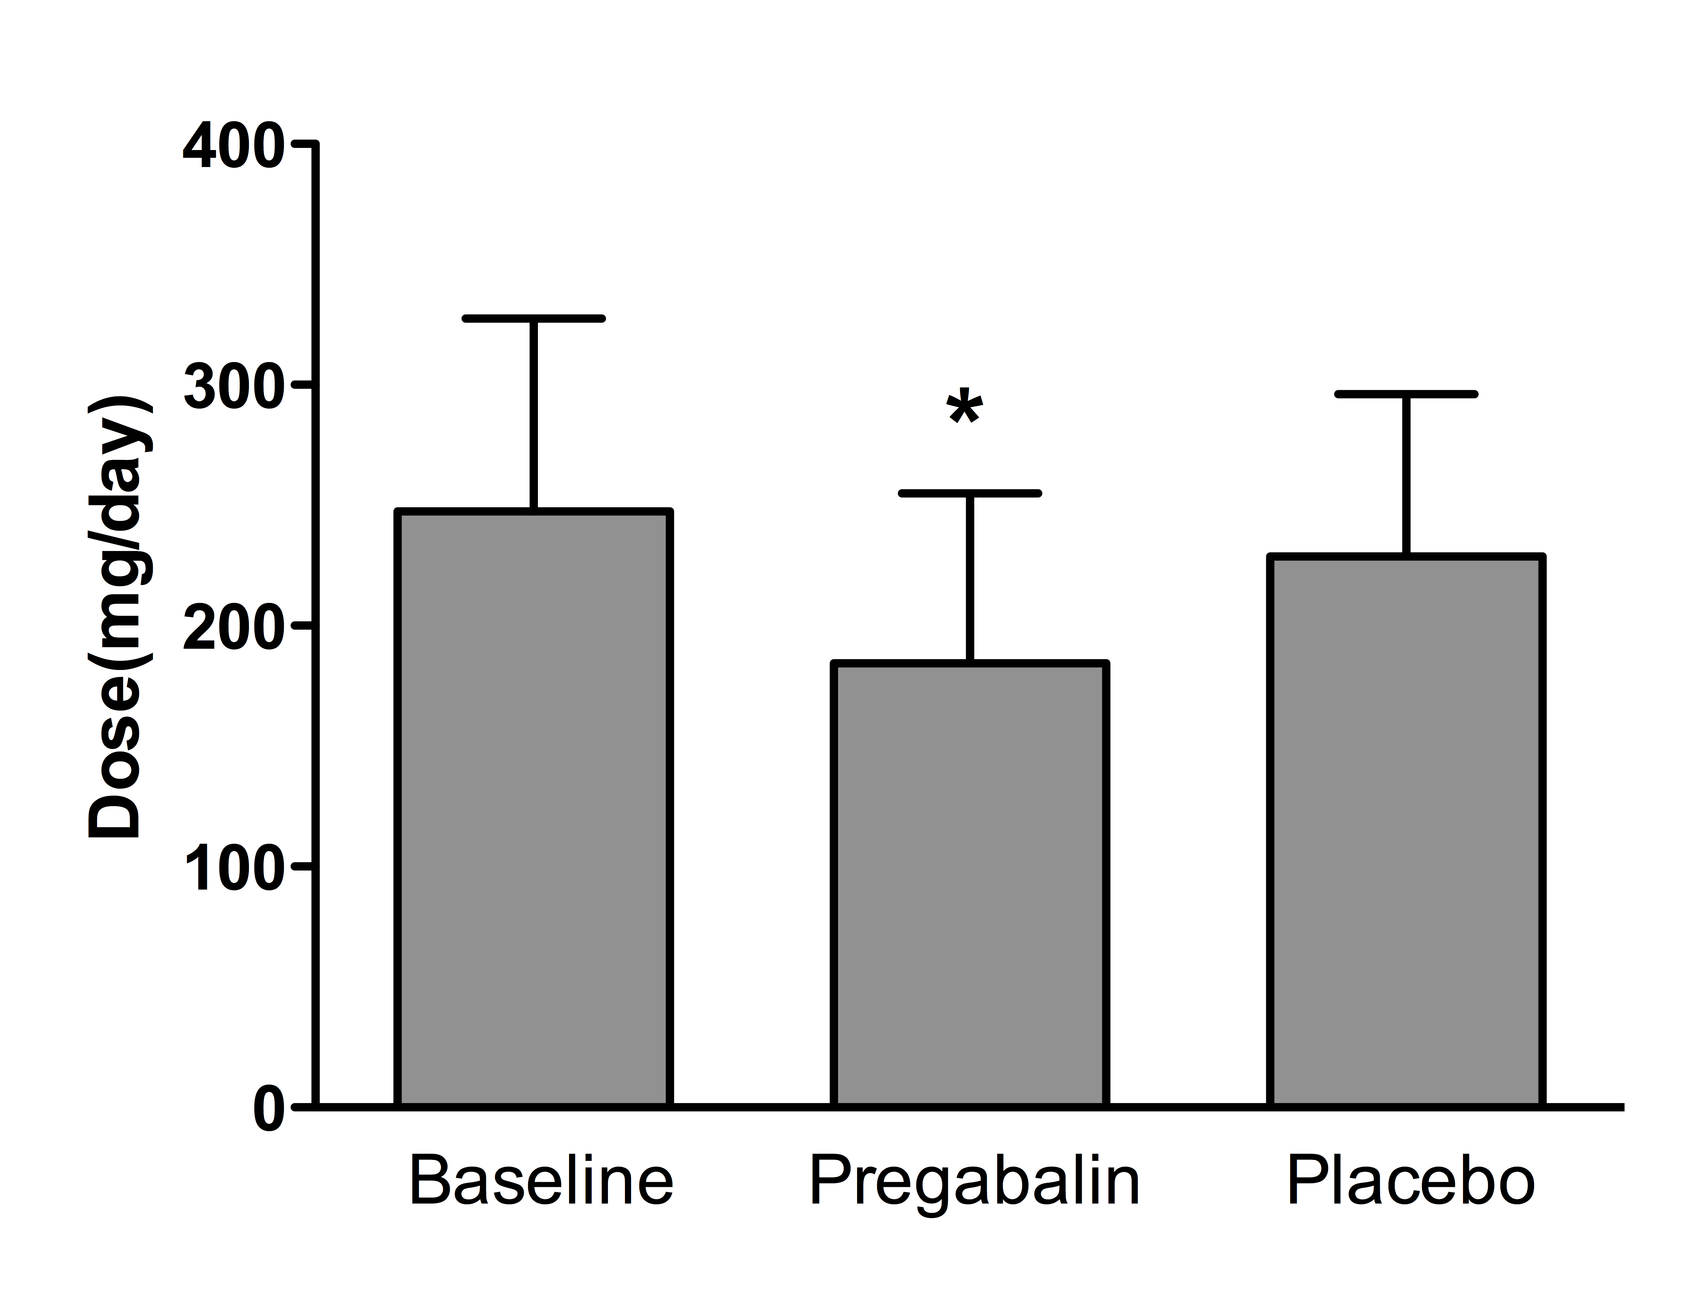

Figure. Minimal Effective Doses of Morphine
The figure shows the mean (±SD) minimal effective doses of morphine when it used as single agent or combined with pregabalin and placebo. *P＜0.001 for the comparison of the pregabalin-morphine combination with placebo-morphine combination.

